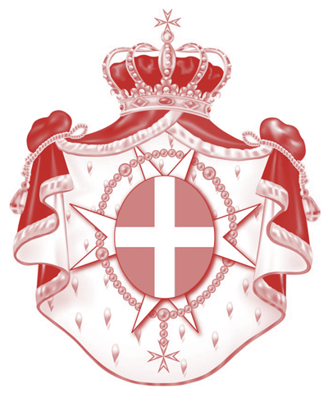
sovereign military hospitaller Order
of St. John of Jerusalem of Rhodes and of Malta
_____
permanent observer mission to the united nations office
and other international organizations in Geneva

Statement by Professor Michel Veuthey
Deputy Permanent Observer to the U.N. in Geneva
Ambassador to monitor and combat trafficking in persons
Geneva, 17 May 2019 Global Platform for Disaster Risk Reduction (GP2019)
The Sovereign Order of Malta would like to thank the Government of Switzerland for hosting so well the sixth Session of the Global Platform for Disaster Risk Reduction (GP2019) and the UN Office for Disaster Risk Reduction (UNDRR) for their excellent preparatory work.
The Sovereign Order of Malta, founded 900 years ago, is one of the oldest Christian Faith-based humanitarian organizations. It maintains diplomatic relations with 108 countries and with the European Union, and has permanent observer status at the United Nations. It has official relations with other countries and international organizations such as the African Union, the Council of Europe, the Community of Portuguese Language Countries, the Indian Ocean Commission, the International Organization of Francophonie, the Parliamentary Assembly of the Mediterranean, the Interamerican Development Bank, UNIDROIT and UNILAT. It has 120,000 Members, professionals and volunteers active in 120 countries. A lay religious order of the Catholic Church since the 12th century (1113) and a subject of international law, it concluded more than 55 cooperation agreements. Through humanitarian operations and diplomacy, both bilateral and multilateral, it promotes respect for human life and dignity, religious freedom, solidarity towards all human beings in need without any discrimination. Its worldwide relief agency, Malteser International, has its General Secretariat and European headquarters in Cologne, Germany.
Its American headquarters are based in New York.
The Order of Malta and Malteser International help communities make emergency plans and implement protective measures to reduce the risk of disaster. Malteser International has implemented disaster risk reduction projects in many countries in Africa, in the Americas, in Asia and the Middle East.
As a founding member of the Disability inclusive Disaster Risk Reduction Network (DiDRRN), we contributed to shape disability inclusion in the Sendai Framework for Disaster Risk Reduction. The Order of Malta places a special focus on people with disabilities and their active participation in disaster preparedness.
The Order of Malta would also like to stress the importance of families in disaster risk reduction and recovery, as well as the role of Faith-inspired organizations and institutions (FBOs). FBOs, having the trust of local communities are often the first in, and the last out in disasters and crises.
It is a fact that FBOs are deeply woven into the fabric of many local populations affected by disasters and conflicts. The strengths and resources of FBOs could complement those of other DRR stakeholders.
The Order of Malta would like to emphasize the role of spiritual values, which are synonymous with and supportive of fundamental human rights, humanitarian rules (in particular Common Article 1 and Article 3 to the 1949 Geneva Conventions) and principles (humanity, neutrality, impartiality, independence, as well as subsidiarity and solidarity). These fundamental rules and principles should be respected in all circumstances – in natural disasters, internal strife, and armed conflicts – by all stakeholders, Governments and non-State actors, for the protection of the life and dignity of all human beings, beginning with affected individuals, families, and communities.
Protection means prevention and should always be a part of it. National, regional, and international legal instruments of international humanitarian law, human rights, refugee law, as well as customary law should provide protection for all, including relief and medical workers, as well as for religious personnel.
Universal religious values of solidarity and respect for life and human dignity could contribute to the effective implementation of fundamental rules and principles of human rights, refugee law, and international humanitarian law applicable in armed conflict. The respect for these rules and values effectively reduces risks and paves the way for conflict prevention and settlement, reconstruction and reconciliation.
The Order of Malta actively participated in the Sendai (2015) and Cancún (2017) Global Platforms.
The Order of Malta will continue to work with other religious actors and international and humanitarian organizations on ways to reinforce public conscience for peace, and for the respect of human life and dignity.
www.orderofmalta.int www.malteser-international.org

